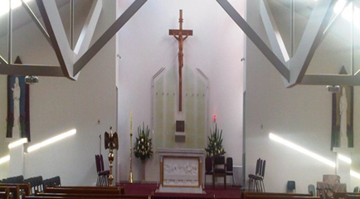
St Kevin’s Catholic Parish, Hampton Park VIC
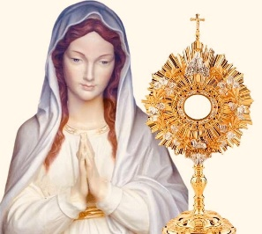
120 Hallam Road, Hampton Park VIC
3976 E-mail: HamptonPark@cam.org.au

REGISTRATION FORM 2025

2025 MARIAN PILGRIMAGE – JUBILEE YEAR
Please complete the Registration Form below and return it with your payment -
(payable to “D’Nazareth Associates”)

Pilgrimage Name: Marian Pilgrimage 2025
13 SEP 2025 – 02 OCT 2025
Cost per person: Double Occupancy $ 10,650.00
Single Supplement $1,900.00
Child Sharing room $ TBA

A non-refundable deposit of $2,000.00 (per person) is due with your completed Registration Form. Your deposit guarantees the plane ticket (because it is non-refundable) and your place on the pilgrimage.

Please use BLOCK letters to complete the Form. Please ensure first names and last name is same as per your Passport.
First Name: Last Name: M F
DOCUMENT COPIES:
Please provide copies of the following documents at the time of registration:

Passport

PAYMENT DETAILS:
D’Nazareth Associates
BSB: 063765
A/C No: 10769149
Street Address: City: State: Postcode: Home phone#: Mobile#: WhatsApp: Yes/No E-mail: Name of Roommate: Single Supplement
Food/Allergies Restrictions:

Emergency contact not traveling: Home phone: Mobile#:
E-mail:

My signature below also verifies that I understand and agree to the Terms and Conditions as stated on this form and on the reverse side of this form.

Signature Required MM/DD/YYYY

TERMS & CONDITIONS
RESERVATIONS
A complete registration form and $2,000.00 per person deposit is required to reserve a spot on this pilgrimage. Space is limited and cannot be guaranteed. Members of St. Kevin’s Catholic Parish will receive priority registration placement followed by family and friends. Deposits are due no later than Friday, 31 January 2025. Reservations can be sent to: D’Nazareth Associates, Attn: Ian D’Nazareth / Email: dnazarethian@gmail.com

PRICING
$10,650.00 cost per person (Based on double occupancy). Payment dates: 1st payment of $2,000.00 per person (at the time of registration), 2nd payment (TBA) and 3rd payment (TBA).

SINGLE SUPPLEMENT
Travelers who desire to have an individual hotel room will be responsible for paying the single supplement of $1,900.00 in addition to the cost above ($10,650+$1,900 = $12,550)

PAYMENT INFORMATION
Your registration is not complete until you have made your $2,000.00 non-refundable deposit. Please attach your bank transfer / deposit copy, to secure your place with this group. See payment information on the first page.

INCLUDED
- Emirates (EK) Flights: MEL – DXB – VCE – LIS – DXB – MEL
- Travel by coach with air conditioning.
- Nights according to program in *** / **** hotels. Meals according to the program - breakfasts, lunches & dinners.
- Tour-guide care over the entire pilgrimage route and local guides. Tour guide system.
- Tips for local staff, licensed tour guide, local guides, entrances, and local taxes.

NOT INCLUDED
- Drinks during meal. PCR TESTS. If necessary, visas from different countries.

ITINERARY CHANGES
St. Kevin’s Catholic Parish, Hampton Park and D’Nazareth Associates reserves the right to amend the itinerary without notice.

CANCELLATION
Cancellation in writing must be received by St. Kevin’s Catholic Parish, Hampton Park no later than
28 February 2025. Deposits are non-refundable.

TRANSPORTATION
General seats on the plane and the bus.

LUGGAGE
One suitcase 23 kg is permitted and one carry-on 7 kg. Traveler must be able to transport suitcase to/from airport to/from bus to/from hotel.

TRAVEL & MEDICAL INSURANCE
It is highly recommended that all travelers take Travel & Medical Insurance.

TRAVEL DOCUMENTS
The travel document is a valid passport not less than 6 months old.

SPECIAL TERMS AND CONDITIONS
The 2025 Marian Pilgrimage Group will proceed once it reaches the minimum number of pilgrims required.
All pilgrims MUST travel along with the group on the same flights.

